**RHYTHMIC TUNES: YOUR MELODIC COMPANION**

REACT.JS

**PROJECT REPORT**

**SUBMITTED TO THE NAAN MUDHALVAN IN THE PARTIAL**

**FULFILLMENT OF THE REQUIREMENT FOR THE**

**DEGREE OF BACHELOR OF COMPUTER APPLICATION**

**BY**

**TEAM LEADER: GOPINATH K**

**TEAM MEMBER 1: SHANMUGAM G**

**TEAM MEMBER 2: ARUN KUMAR V**

**TEAM MEMBER 3: HEMACHANDRAN E**

**TEAM MEMBER 4: BHARATH R**



**DEPARTMENT OF COMPUTER APPLICATION**

**HINDUSTAN COLLEGE OF ARTS AND SCIENCE**

**PADUR,KELAMBAKKAM**

**MARCH-2025**

**INTRODUCTION**

The rapid evolution of music streaming and digital platforms has transformed how we discover, listen to, and share music. Rhythmic Tunes aims to bridge the gap between music enthusiasts and the melodies they love by offering a seamless and personalized listening experience. This project explores the integration of user-centric features, intelligent recommendations, and a sleek interface to enhance music discovery and enjoyment. By leveraging React.js for a dynamic and responsive UI, Rhythmic Tunes provides an intuitive platform for users to explore various genres, create playlists, and connect with a community of music lovers.

**PROJECT OVERVIEW**

Rhythmic Tunes is designed to redefine the music listening experience through a modern and interactive web application. Built using React.js, the project emphasizes a component-based architecture for efficiency and scalability. Key features include personalized recommendations, curated playlists, and real-time search capabilities. The application’s intuitive design ensures a smooth user experience, while the use of APIs enables seamless integration with a vast music library. Additionally, Rhythmic Tunes incorporates advanced algorithms for song suggestions based on listening habits and mood analysis, enhancing personalization. Security measures like encrypted data storage and secure login systems ensure user privacy. The project also envisions future enhancements, including offline listening and community-driven playlist curation, to further enrich the user experience. By combining sleek visuals with powerful functionality, Rhythmic Tunes seeks to become the go-to platform for music enthusiasts.

**ARCHITECTURE**

The architecture of Rhythmic Tunes follows a modular and scalable approach using React.js for the frontend and a RESTful API to manage backend communications. The frontend leverages reusable components to streamline development and ensure consistency across the application. State management is handled using Context API and Redux for complex state scenarios, ensuring efficient data flow. The backend, designed to be flexible, interacts with a cloud-based database to manage user information, playlists, and preferences securely. The integration of APIs for music streaming and user authentication further enhances the app’s capabilities. Security layers, including HTTPS protocols and token-based authentication, safeguard user data. This architecture ensures that Rhythmic Tunes can handle high traffic and expand with additional features seamlessly.

**USER INTERFACE**

The user interface of RhythmicTunes is designed to be visually appealing and easy to navigate, prioritizing user experience and accessibility. It features a clean, modern layout with intuitive navigation bars, dropdowns, and responsive design to ensure compatibility across different devices. Customizable themes and a dark mode option enhance the user experience, catering to individual preferences. Interactive elements like animated buttons, progress bars, and hover effects provide a dynamic feel, while the seamless integration of music controls ensures an uninterrupted listening experience. The UI also includes search filters, genre-based browsing, and personalized dashboards to simplify content discovery and management.

**SETUP INSTRUCTIONS**

To set up Rhythmic Tunes locally, ensure that Node.js and npm are installed on your system. Clone the project repository from GitHub and navigate to the project directory. Run 'npm install' to install the required dependencies, followed by 'npm start' to launch the application in development mode. For backend services, configure the API endpoints and environment variables in the .env file. The application is designed to work seamlessly with a cloud-based database, but you can also configure it for local testing using a MongoDB instance. Make sure to install any required plugins for authentication and music streaming APIs. For a production build, use 'npm run build' to generate optimized files ready for deployment.

**FOLDER STRUCTURE**

The folder structure for RhythmicTunes follows best practices for React applications, ensuring modularity and maintainability. Key folders include:

* **Src/**: Contains all the source code, including components, contexts, and assets.
  + **components/**: Houses reusable UI components like buttons, cards, and modals.
  + **pages/**: Contains individual pages such as Home, Library, and Profile.
  + **contexts/**: Manages global state using Context API.
  + **services/**: Handles API calls and authentication logic.
  + **assets/**: Stores images, icons, and custom fonts.
  + **styles/**: Centralizes CSS and styled-components for a consistent design

**RUNNING THE APPLICATION**

To run RhythmicTunes, open the terminal in the project directory and execute 'npm start'. This command starts the development server and opens the application in the default web browser at 'http://localhost:3000'. For backend services, ensure that the API server is running and all necessary environment variables are configured. Use 'npm run build' for production mode, which generates static files in the 'build' folder. These files can be deployed to platforms like Vercel, Netlify, or GitHub Pages for public access. Monitoring tools and console logs help in tracking errors and performance issues during runtime.

**COMPONENT DOCUMENTATION**

The component-based architecture of RhythmicTunes ensures reusability and maintainability across the application. Key components include:

* **Header**: Manages navigation, search bar, and user profile access.
* **Music Card**: Displays song information with play, pause, and add-to-playlist options.
* **Playlist Manager**: Handles creation, editing, and deletion of playlists.
* **Auth Form**: Manages user authentication using forms for login and registration.
* **Music Player**: Provides controls for play, pause, skip, and volume adjustments.
* **Sidebar**: Facilitates easy navigation between Home, Library, and Settings.

**STATE MANAGEMENT**

State management in RhythmicTunes is primarily handled using Context API for simpler state needs and Redux for more complex scenarios. The Context API efficiently manages global states like user authentication, theme preferences, and current track information without prop drilling. For more intricate state transitions, such as managing playlists, search results, and playback history, Redux is utilized due to its ability to handle asynchronous actions with middleware like Redux Thunk. Combining these approaches ensures that the application remains performant and maintainable, with a clear and predictable data flow.

**The Hybrid Model: COMBINING THE STRENGTHS OF CLOUD AND LOCAL STORAGE**

The hybrid model in RhythmicTunes leverages both cloud and local storage to optimize performance and accessibility. Cloud storage is used for user data, playlists, and preferences, ensuring data is accessible across multiple devices. Local storage is employed to cache frequently accessed data like song metadata and playback history, reducing API calls and improving load times. This approach not only enhances the user experience by minimizing latency but also ensures that core functionalities remain accessible even during network disruptions. By integrating cloud-based scalability with the speed of local storage, RhythmicTunes offers a balanced solution that meets both performance and reliability demands.

**STYLING**

RhythmicTunes embraces a visually appealing and modern design, combining vibrant colors and smooth animations to enhance user engagement. The platform's use of CSS modules and styled-components ensures a consistent and professional look across all devices. With customizable themes and a dark mode option, RhythmicTunes caters to diverse user preferences. The UI elements, such as cards, buttons, and sliders, follow a minimalist approach, focusing on clarity and ease of use. By leveraging responsive design techniques, the application ensures a seamless experience for users on desktops, tablets, and smartphones, maintaining its competitive edge in the digital music landscape.

**TESTING**

Testing in RhythmicTunes is conducted through a combination of unit, integration, and end-to-end testing to ensure reliability and performance. Jest and React Testing Library are used for unit tests to validate individual components and their logic. Integration tests verify the seamless interaction between components, focusing on API calls and data handling. For end-to-end testing, Cypress is utilized to simulate real user scenarios, ensuring that all features work as intended across different devices and browsers. Continuous Integration (CI) pipelines automate testing during code deployment, catching issues early and maintaining a stable codebase.

**SOURCE CODE:**

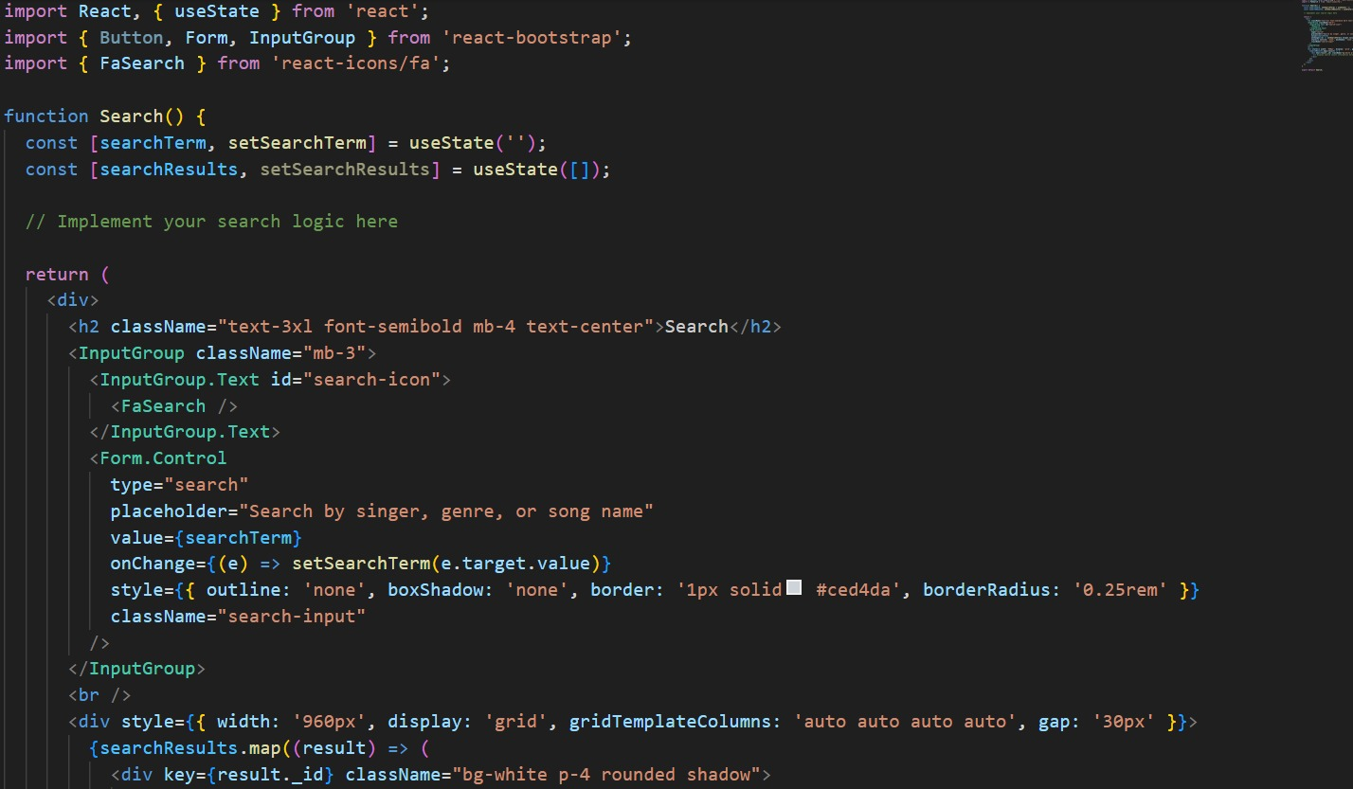

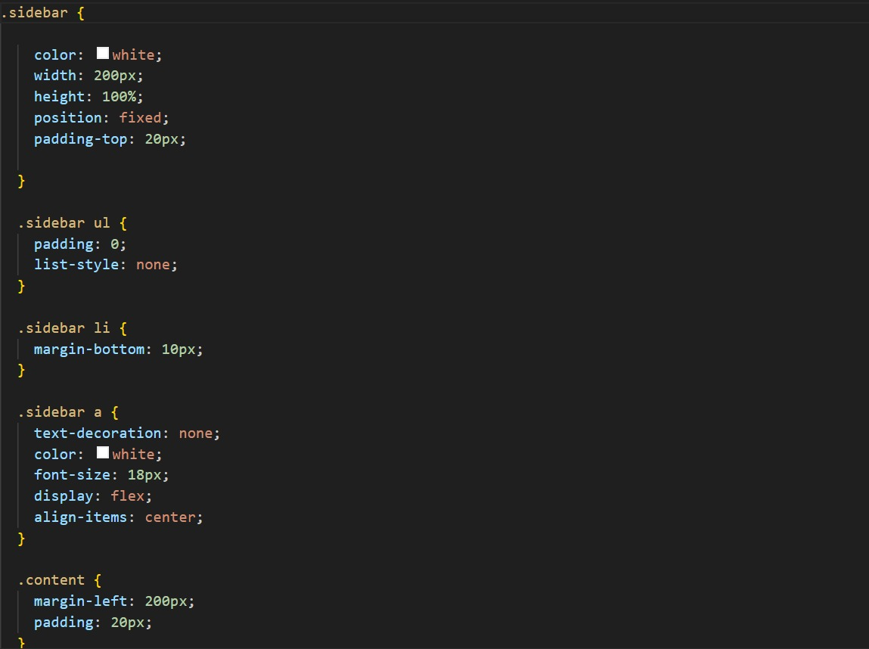

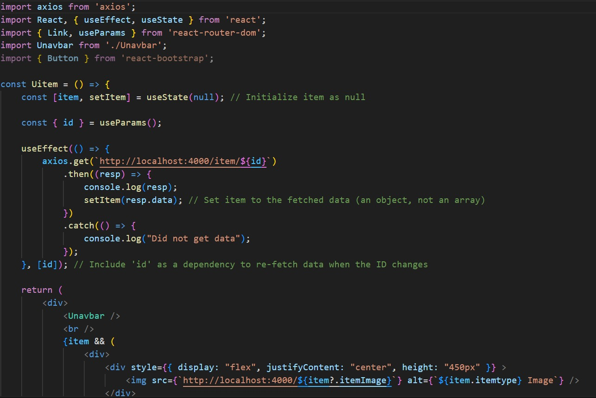

**SCREENSHORT OR DEMO**

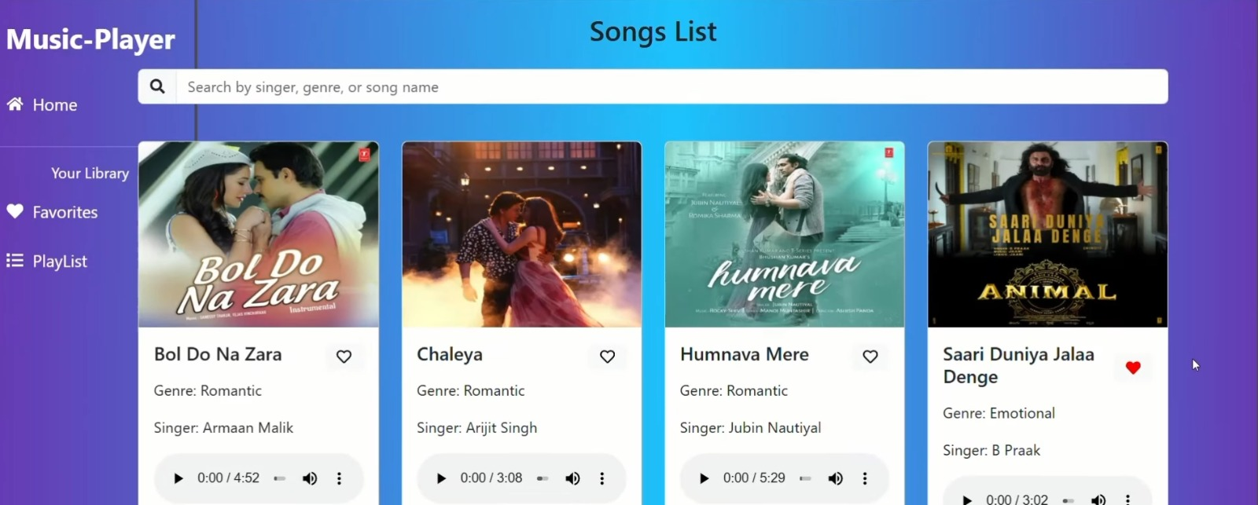

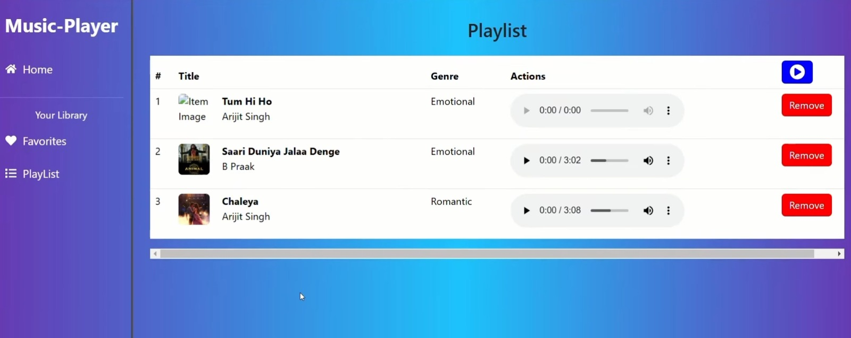

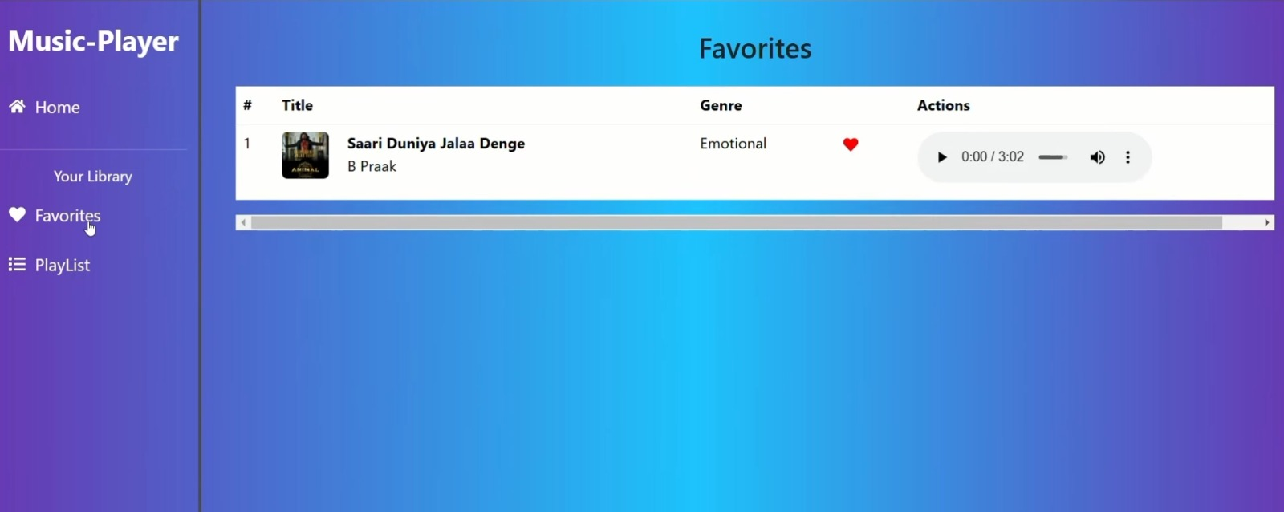

**FUTURE ENHANCEMENTS**

To enhance the user experience, Rhythmic Tunes plans to introduce AI-driven features such as mood-based playlists and real-time lyrics synchronization. Integration with wearables for fitness-based playlists is also under consideration. Expanding the music library through additional API integrations and offline listening capabilities are in the roadmap. Enhancements in social features, like collaborative playlists and in-app messaging, aim to build a community-driven platform. Additionally, multilingual support and advanced analytics for user preferences will help refine recommendations and personalize the music discovery experience.

**CONCLUTION**

RhythmicTunes successfully demonstrates how a modern music streaming platform can combine powerful functionality with a user-centric design. By leveraging React.js for a responsive UI, robust state management techniques, and a hybrid storage model, the application ensures both performance and reliability. The seamless integration of personalized recommendations and secure data handling reflects its commitment to enhancing the user experience. As it evolves with future enhancements, RhythmicTunes is well-positioned to become a leading choice for music enthusiasts seeking a dynamic and personalized listening experience.